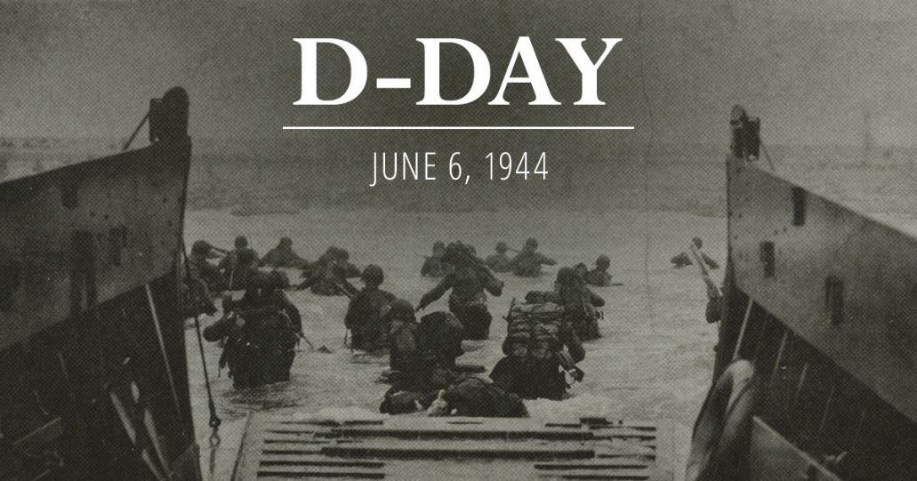
D-Day Invasion
with Professor Gary Hylander
Wednesday, June 7th
7:00—8:00 PM
Norfolk Public Library

Operation Overlord, the Allied invasion of Europe, began on June 6, 1944. The greatest armada the world had ever seen began to assemble in the pre-dawn hours off the French coastline in preparation for the final assault upon Hitler's Germany. In his General Order for the day Eisenhower called the attack a "great crusade" and assured the soldiers about to storm the Normandy beaches that the "hopes and prayers" of the free world "march with you."

Free and open to the public. Sponsored by the Friends of the Norfolk Public Library.

